**SMU Library**

Objectives:

1. Understand how to use SMU's online library

**Citation components**

Objectives:

1. Understand the important components that go into a citation (4 Ws)
2. Understand the general citation format for different sources (book, journal, website, newspaper, etc.)

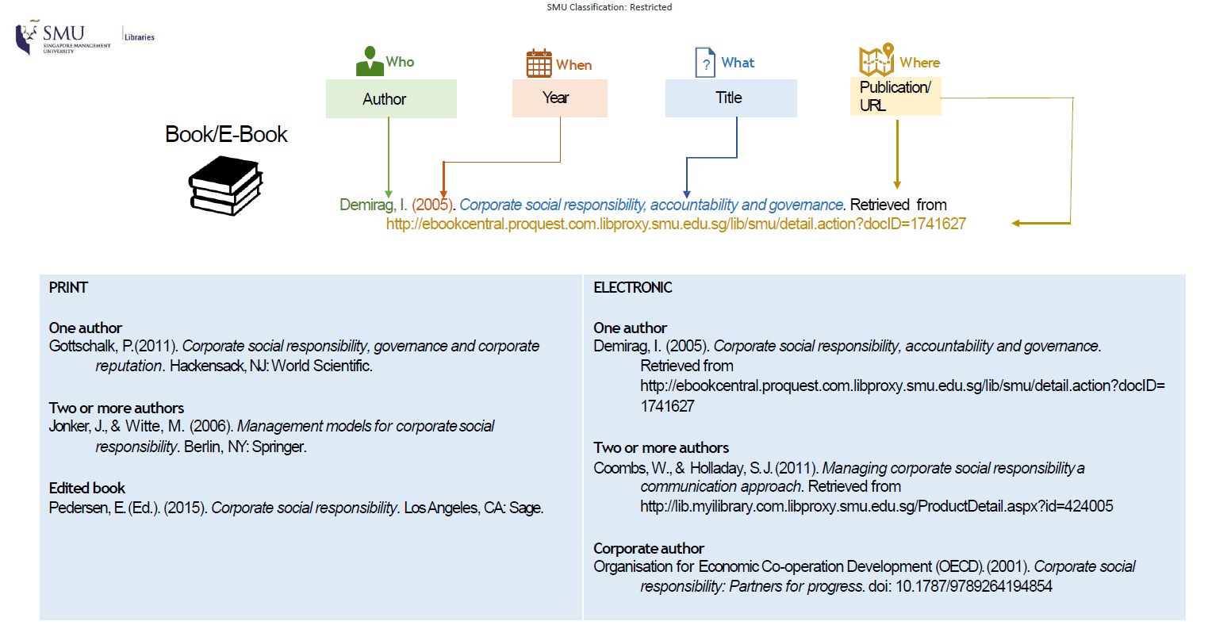

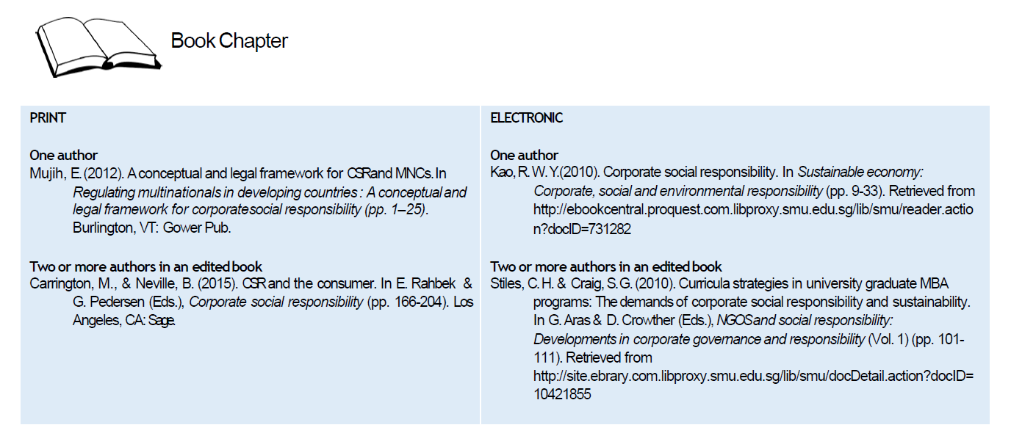

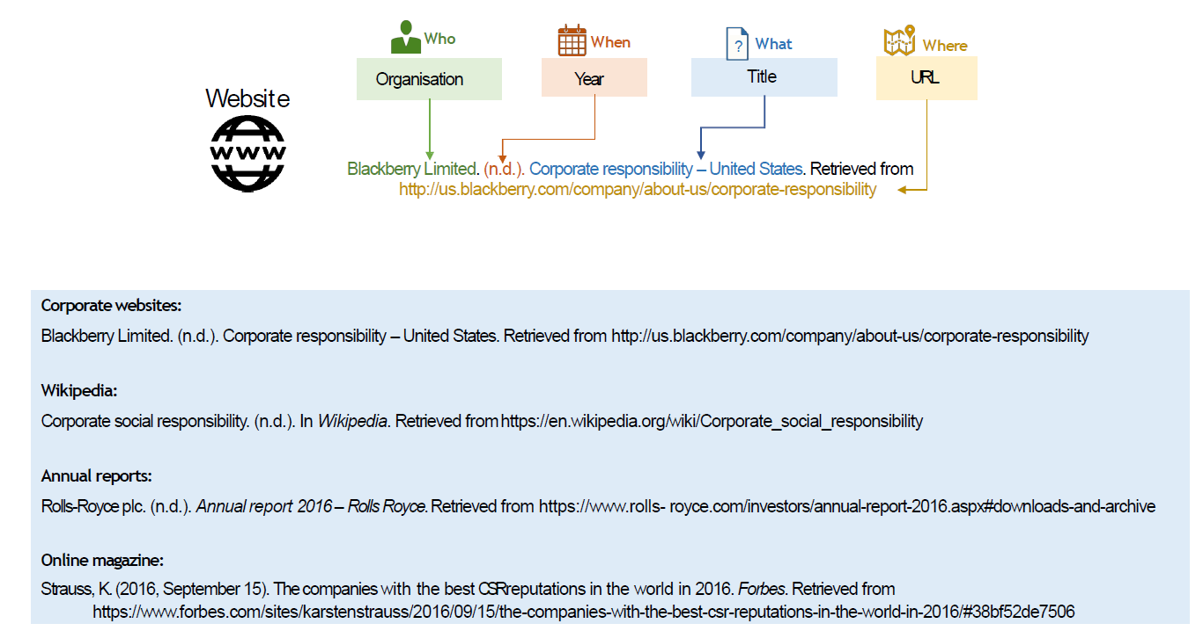

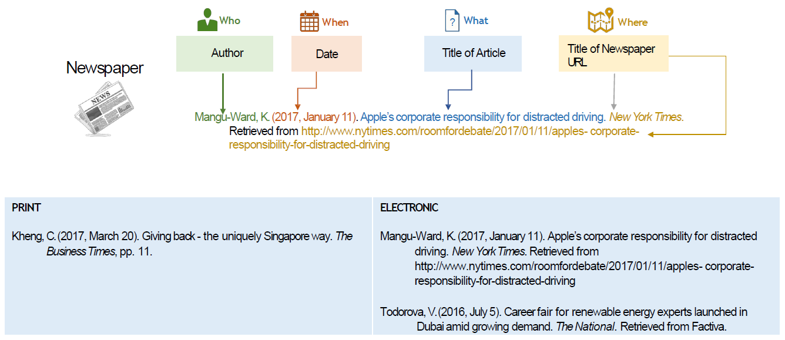

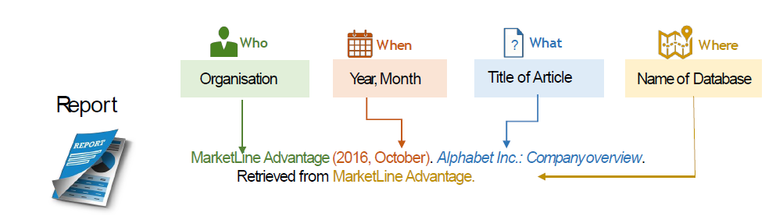

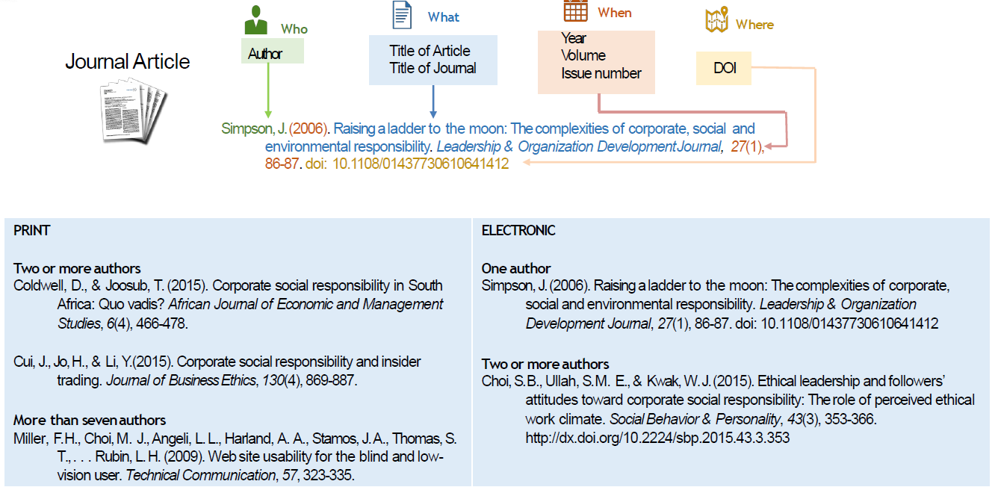

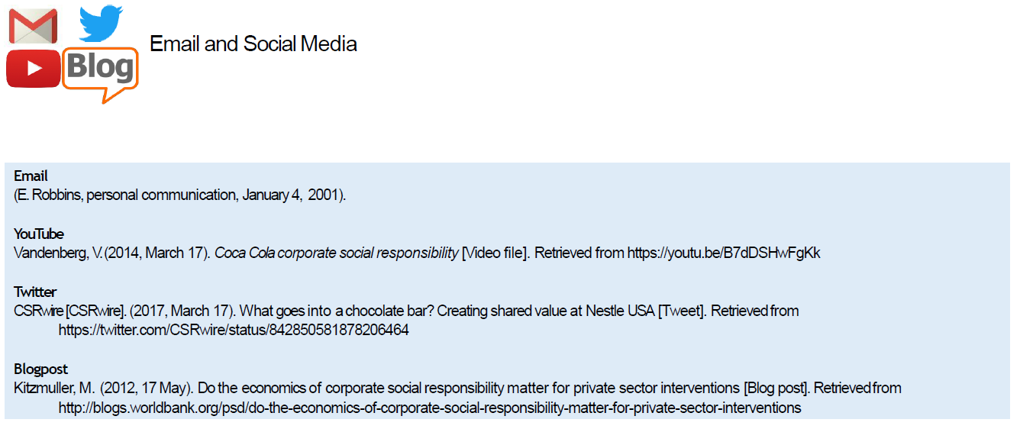

**In-text citations**

Objectives:

1. Understand how to use in-text citation in written reports

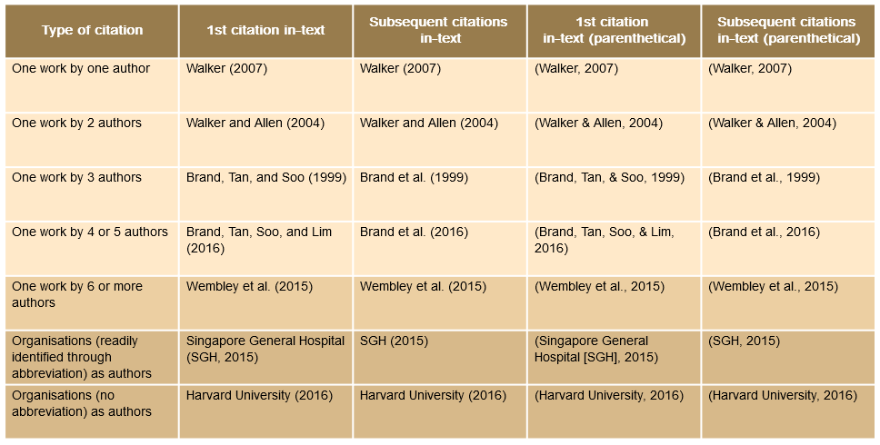

* If <6 authors, after citing all for the first time, you may use *et al* in further in-text citations
* If there is no author or publisher, include the **title** or an abbreviation of it, in *italics*
* If there are 2 or more resources in the same citation, separate with a **semicolon (Rogers, 2014; CSRWire, n.d.)**
* For authors with the same name, include **initials** as well **(A. Vandenburg, 2014; B. Vandenburg, 2017)**
* For resources by the same author in the same year, include lowercase letters **(Jones, 2014a; Jones, 2014b)**

**Reference list (APA citation)**

Objectives:

1. Understand how to add a reference list or bibliography to your article in APA format\

* Create references according to APA guidelines
* Use correct punctuation. Know when to italicise (*book titles*, *journal titles*, *volume numbers*)
* Indentation. References must be indented from the left from the second line onwards
* Arrange in alphabetical order, by name of author

**Citation Generation**

Objectives

1. Understand how to generate citations (APA), and the tools available to you
2. Mendeley, Zotero, Endnote as citation programs

* Copy citation straight from SMU library website
* Google scholar
* Citation Machine

**Plagiarism**

Objectives:

1. Understand techniques to avoid plagiarism

* Quoting - directly referencing the source text within inverted commas
* Summarising - Condensing the gist of an article
* Paraphrasing - Not summarising, but describing a given idea in your own words